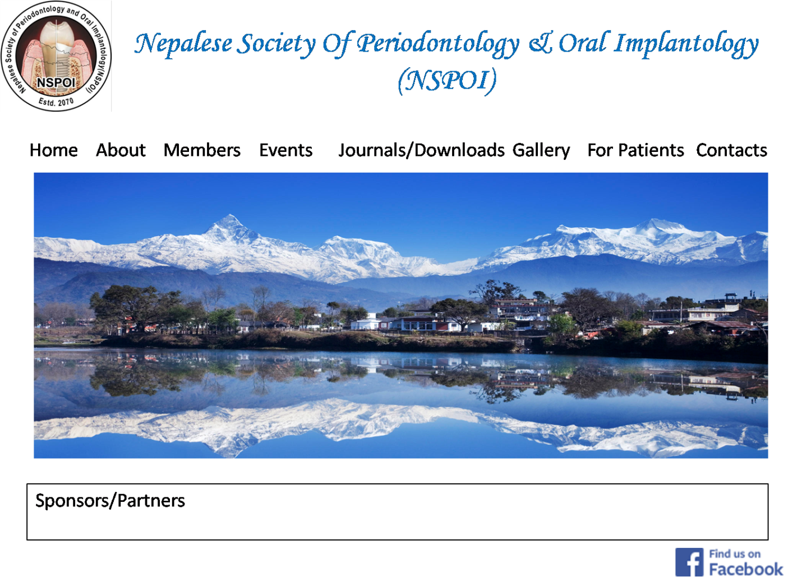

HOME

Nepalese Society of Periodontology and Oral Implantology ( NSPOI), a non profit organization of all the periodontist, dental surgeons practicing periodontology and oral implantology in the country, was founded on 8th January 2014. The founder members of the society composed of 13 members M.D.S. (Periodontics).

NSPOI aims to promote periodontal and peri-implant tissue health in Nepal. It is heading ahead with the purpose to improve the awareness regarding Periodontology and Oral Implantology among general public and to conduct relevant programs to keep updated regarding latest technologies on a regular basis.

ABOUT

* Aims and Objectives
* Message from President/General Secretary
* Executive Founder Members
* Executive Members

Aims and Objectives

* This is a non-profit organization formed with the purpose of serving people of Nepal.
* All the members of this society are Periodontists, practicing Periodontology and Oral Implantology in the country working together for the professional upliftment and actively participate to sort out problems of members of NSPOI
* To improve the awareness regarding Periodontology and Oral Implantology among in general public and to conduct relevant programs to keep updated regarding latest technologies on a regular basis.
* NSPOI assists the government to make necessary improvements and amendments in the field of Periodontology and Oral Implantology as well to help the students of postgraduate in Periodontics in Nepal regularly towards progress and betterment.
* To provide professional advice/ counseling/ consultation expertise to Nepal government and various other institutions.
* To advise related body/ institute to make timely changes/ improvements in the current Periodontology and Oral Implantology services and to suggest necessary changes to improve the skills and expertise of specialists
* To foster the academic relationship among health care providers with interest in periodontal and peri-implant health
* To conduct trainings, researches, seminars, conferences related to the field of Periodontology and Oral Implantology.
* To provide/ contribute necessary advice and help to concerning government and non-government organizations to control unauthorized illegal practices related to the field of Periodontology and Oral Implantology
* To give/ provide membership to non-government National and International Organizations related to Periodontology and Oral Implantology

**Message from President/General Secretary**

It is with great pleasure that we would like to welcome you to the website of Nepalese Society of Periodontology and Oral Implantology (NSPOI); the official Organization for the specialty of Periodontology & Implantology in Nepal. We are recently formed society with handful members as one of the most active dental specialty organizations in Nepal. Please feel free to browse through the site and explore the areas we represent in the specialty of periodontology and Oral Implantology and the members may login to access personal information and registration details; provided they are assigned a user-name and password for the same.

Executive Founder Members

1. Dr. Shaili Pradhan
2. Dr. Rita Singh
3. Dr. Surendra Man Shrestha
4. Dr Durga Pun
5. Dr Shivalal Sharma
6. Dr Sameer Aryal
7. Dr Manoj Humagain
8. Dr Bhageshwar Dhami
9. Dr Priti Shrestha
10. Dr Junima Rajkarnikar
11. Dr Ameena Pradhan
12. Dr Dhirendra Kumar Giri
13. Dr Ranjita Shrestha Gorkhali

Executive Members

1. Dr Shaili Pradhan (President)
2. Dr Rita Singh (Vice-President)
3. Dr Manoj Humagain (General Secretory)
4. Dr. Sameer Aryal /Dr. Ranjita Shrestha Gorkhali (Treasurer)

Members

1. Dr. Surendra Man Shrestha
2. Dr. Bhageshwar Dhami
3. Dr. Junima Rajkarnikar

Registered Periodontists in Nepal

and

Members of NSPOI

1. Dr Shaili Pradhan
2. Dr Rita Singh
3. Dr. Surendra Man Shrestha
4. Dr Durga Pun
5. Dr Shivalal Sharma
6. Dr Sameer Aryal
7. Dr Manoj Humagain
8. Dr Bhageshwar Dhami
9. Dr Priti Shrestha
10. Dr Junima Rajkarnikar
11. Dr Ameena Pradhan
12. Dr Dhirendra Kumar Giri
13. Dr Ranjita Shrestha Gorkhali
14. Dr Khushboo Goel
15. Dr Sweta Rajya Laxmi Rana
16. Dr Dikshya Katwal
17. Dr Sunita Sharma
18. Dr Mahima Subba
19. Dr Sajeev Shrestha
20. Dr Mohana Giri
21. Dr. Bhagwat Bhattaarai
22. Dr. Deepesh Bikram Thapa

Events

* Past events
* Upcoming events

Journals/Downloads

* Membership form

Gallery

* Pictures (During NSPOI formation)
* Clinical meetings
* 1st Annual Conference

For Patients

* What is Periodontology?
* Who is a Periodontist/Periodontal Specialist?
* What is Periodontitis (Gum Disease)?
* Causes of Gum Disease
* Symptoms of Gum Disease
* Diagnosis of Gum Disease
* Treatment of Gum Disease
* Goals of Gum treatment
* Prevention of Gum Disease
* Risk Factors
* Linking Gum Disease to other Health problems
* Periodontal treatments and procedures
* About Dental Implants

What is Periodontology?

* **Periodontology** or **Periodontics**  is the specialty of dentistry that studies supporting structures of teeth, as well as diseases and conditions that affect them.
* The supporting tissues are known as the [periodontium](https://en.wikipedia.org/wiki/Periodontium), which includes the gingiva (gums), alveolar bone, cementum, and the periodontal ligament.

## Who is a Periodontist or Periodontal Specialists?

A periodontist is a dentist who specializes in the prevention, diagnosis, and treatment of periodontal disease, and in the placement of dental implants.

Periodontists receive extensive training in these areas, including three additional years of education to earn master of dental surgery in periodontics i.e.MDS after completing BDS i.e Bachelors of dental surgery.

They are familiar with the latest techniques for diagnosing and treating periodontal disease, and are also trained in performing cosmetic periodontal procedures.

* **What is Periodontitis (Gum Disease)?**

Periodontitis, also generally called gum disease or periodontal disease, begins with bacterial growth in your mouth and may end -- if not properly treated -- with tooth loss due to destruction of the tissue that surrounds your teeth.

CAUSES OF GUM DISEASE

Plaque is the primary cause of gum disease. However, other factors can contribute to periodontal disease. These include:

* **Hormonal changes:** pregnancy, puberty, menopause, and monthly menstruation, make gums more sensitive, which makes it easier for gingivitis/gum disease to develop.
* **Illnesses: diseases like cancer,HIV,diabetes etc**  may interfere with the immune system and affect the condition of your gums.
* [Medications:   Some drugs, such as the anticonvulsant medication](http://www.webmd.com/drugs/index-drugs.aspx)[Dilantin](http://www.webmd.com/drugs/2/drug-4157/dilantin+oral/details) and the anti-[angina](http://www.webmd.com/heart-disease/guide/heart-disease-angina)drug [Procardia](http://www.webmd.com/drugs/2/drug-10981/procardia+oral/details) and [Adalat](http://www.webmd.com/drugs/2/drug-8964/adalat+oral/details), can cause abnormal growth of gum tissue.
* **Bad habits**:Smoking is a risk factor for gum disease
* **Poor oral hygiene habits:improper brushing/flossing and inadequate oral hygiene practice,** make it easier for gingivitis to develop.
* **Family history of dental disease** can be a contributing factor for the development of gingivitis.

SYMPTOMS OF GUM DISEASE

* Gums that bleed during and after tooth brushing
* Red, swollen, or tender gums
* Persistent bad breath or bad taste in the mouth
* [Receding gums](http://www.webmd.com/oral-health/guide/receding_gums_causes-treatments)
* Formation of deep pockets between teeth and gums
* Loose or shifting teeth
* Changes in the way teeth fit together upon biting down, or in the fit of partial dentures.

Gum disease may progress painlessly, producing few obvious signs, even in the late stages of the disease.Even if you don't notice any symptoms, you may still have some degree of gum disease. Only a dentist or a periodontist can recognize and determine the progression of gum disease.

DIAGNOSIS OF GUM DISEASE

During a dental exam, your dentist typically checks for these things:

* Gum bleeding, swelling, firmness, and pocket depth (the space between the gum and tooth; the larger and deeper the pocket, the more severe the disease)
* Teeth movement and sensitivity and proper teeth alignment
* Your jawbone, to help detect the breakdown of bone surrounding your teeth

TREATMENT OF GUM DISEASE

Treatment options depend on the stage of disease, how you may have responded to earlier treatments, and your overall health. Options range from nonsurgical therapies that control bacterial growth to surgery to restore supportive tissues.

**GOALS OF GUM TREATMENT**

* to promote reattachment of healthy gums to teeth
* to reduce swelling
* to reduce the depth of pockets, and the risk of infection
* to stop disease progression.

PREVENTION OF GUM DISEASE

In most of the cases, gum disease can be reversed when proper plaque control is practiced. Proper plaque control consists of professional cleanings at least twice a year and daily brushing and flossing. According to the American Dental Association, antibacterial [mouth](http://www.webmd.com/oral-health/rm-quiz-mouth-myths) rinses can reduce bacteria that cause plaque and gum disease,

**RISK FACTORS**

**Following factors** can increase the severity, and speed of gum disease:

* [**SMOKING**](http://www.webmd.com/smoking-cessation/ss/slideshow-13-best-quit-smoking-tips-ever) AND TOBACCO USE**:** [Tobacco](http://www.webmd.com/smoking-cessation/ss/slideshow-tips-quit-smoking) users and smokers are seven times more likely to get gum disease than nonsmokers. Also [smoking](http://www.webmd.com/smoking-cessation/quit-smoking-11/rm-quiz-stop-smoking) can lower the chances of success of some treatments including dental implants.
* [**STRESS**](http://www.webmd.com/balance/stress-management/stress-management-relieving-stress)**:** Stress may make it difficult for your body's immune system to fight off infection.
* **BALANCED DIET:** Eating foods with [antioxidant](http://www.webmd.com/food-recipes/how-antioxidants-work1) properties -for example,those containing [vitamin E](http://www.webmd.com/vitamins-supplements/ingredientmono-954-vitamin+e.aspx?activeingredientid=954&activeingredientname=vitamin+e) (vegetable oils, nuts, green leafy vegetables)and [vitamin C](http://www.webmd.com/vitamins-supplements/ingredientmono-1001-vitamin+c+ascorbic+acid.aspx?activeingredientid=1001&activeingredientname=vitamin+c+(ascorbic+acid)) (citrus fruits, broccoli, potatoes) -- can help your body repair damaged tissue. Proper [nutrition](http://www.webmd.com/diet/rm-quiz-nutrition-iq) helps your immune system fight infection.
* **CLENCHING AND**[**GRINDING TEETH**](http://www.webmd.com/oral-health/guide/teeth-grinding-bruxism)**:** These actions may put excess force on the supporting tissues of the teeth and could increase the rate at which these tissues are destroyed.
* **GENETIC SUSCEPTIBILITY:** If anyone in your family has gum disease, it may mean that you are at greater risk as well. Genetically predisposed individuals may be up to six times more likely to develop some form of gum disease.

LINKING GUM DISEASE TO OTHER HEALTH PROBLEMS

Under certain circumstances,researchers have revealed potential links between gum disease and other serious health conditions such as [Diabetes](http://www.webmd.com/diabetes/diabetes-health-check/default.htm),heart disease,preterm low birth rates,respiratotory disease etc.

PERIODONTAL [TREATMENTS AND PROCEDURES](https://www.perio.org/consumer/treatments-procedures)

* [Non-Surgical Periodontal Treatments](https://www.perio.org/consumer/non-surgical)
* [Gum Graft Surgery](https://www.perio.org/consumer/grafts.htm)
* [Laser Treatment for Gum Disease](https://www.perio.org/consumer/laser-therapy.htm)
* [Regenerative Procedures](https://www.perio.org/consumer/regeneration.htm)
* [Dental Crown Lengthening Procedure](https://www.perio.org/consumer/dental-crown-lenghthening.htm)
* [Dental Implants](https://www.perio.org/consumer/dental-implants)
* [Periodontal Pocket Reduction Procedures](https://www.perio.org/consumer/pocket-reduction-procedures.htm)
* [Periodontal Plastic Surgery Procedures](https://www.perio.org/consumer/plastic-surgery-procedures)

**Dental Implants: Replacement Teeth That Look and Feel Like Your Own**

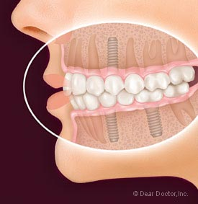

A dental implant is an artificial tooth root that a periodontist places into your jaw to hold a replacement tooth or bridge.

Dental implants are an ideal option for people in good general oral and systemic health who have lost a tooth or teeth due to periodontal disease, an injury, or some other reason.

Under proper conditions,such as placement by a periodontist and diligent patient maintenance,implants can last a lifetime

Advantages of Dental Implants over dentures or a bridge

* Esthetics: Dental implants look and feel like your own teeth
* Tooth saving: Structure of your neighboring teeth are not sacrificed to place or support your implants
* Confidence: Dental implants will allow you to once again to speak and eat with comfort and confidence
* Reliable:The success rate of dental implants is highly predictable